**About NETFLIX**

Netflix is one of the most popular media and video streaming platforms. They have over 10000 movies or tv shows available on their platform, as of mid-2021, they have over 222M Subscribers globally. This tabular dataset consists of listings of all the movies and tv shows available on Netflix, along with details such as - cast, directors, ratings, release year, duration, etc.

**Business Problem**

Analyze the data and generate insights that could help Netflix ijn deciding which type of shows/movies to produce and how they can grow the business in different countries

**Dataset**



The dataset provided to you consists of a list of all the TV shows/movies available on Netflix:

**Show_id:** Unique ID for every Movie / Tv Show  
**Type:** Identifier - A Movie or TV Show  
**Title:** Title of the Movie / Tv Show  
**Director:** Director of the Movie  
**Cast:** Actors involved in the movie/show  
**Country:** Country where the movie/show was produced  
**Date_added:** Date it was added on Netflix  
**Release_year:** Actual Release year of the movie/show  
**Rating:** TV Rating of the movie/show  
**Duration:** Total Duration - in minutes or number of seasons  
**Listed_in:** Genre  
**Description:** The summary description

EXPLORATORY DATA ANALYSIS:

It consists of basic dataset analysis… like columns info, data types of columns , checking null values , handling them , descriptive statistics.

BUSINESS INSIGHTS BASED ON COMPLETE ANALYSIS:

INFERENCE:

There are almost double the movies produced on Netflix than TV shows.

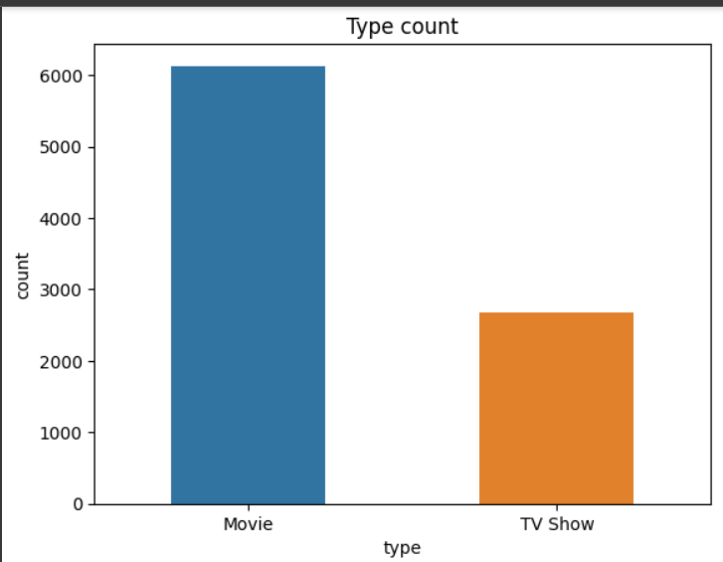

Inference

* China is not among top 5 consumer of Netflix.
* Most of the movies available to watch are rated as MA.
* Most of the TV Shows available to watch are rated as TV-MA.
* Average duration of movies present on Netflix between 80-100 mins.
* Average duration of TV shows present on Netflix is 2 seasons.
* Anupam Kher was starred in maximum number of Netflix movies.
* Takahiro Sakurai was starred in maximum tv shows.
* Ken Burns is the most popular TV show directors over the platform.
* Rajiv Chilaka is the most popular movie directors over the platform.
* There was a downward tresnd observed after 2019 for movies. And 2020 for TV shows.
* Actor/director duo Anupam kher and david Dawan has most movies on Netflix India.
* Most popular genre is International Movies followed by Dramas.

Actionable recommendations for business

* The target audience in USA is recommended to be MA The target audience in India is recommended to be 14+
* Drama & Comedy, International Movies/TV Show are the most popular genres across. all countries.
* 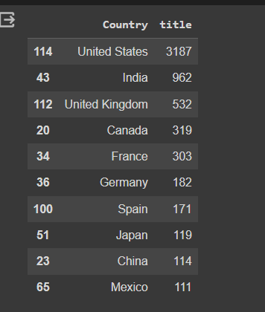
* Above are the top 10 countries with highest content on Netflix. Hence by analysing the data for each country. Different deals can be provided to attract more customers. Also Netflix can focus on interested genre country wise and can increase the input based on that.
* For example, By analysing the data for Japan. It is inferred that Japanese prefer international and animation shows. Hence , Netflix can focus more on international/animation series/shows for Japanese consumers.
* Similary for Indians its international shows then Drama shows and international movies and drama movies.
* Considering the ratings of USA audience. Netflix can focus on more MA rated shows.
* Similarly more shows of age group 14+ can be produced in India for better number of audience.